YARD DUTY AND SUPERVISION POLICY


Help for non-English speakers
If you need help to understand the information in this policy, please contact
the school office on 9741 6300 or via email at manorvale.ps@education.vic.gov.au

SCHOOL MISSION
The school’s purpose is to develop aspirational and optimistic students who have the academic and
social foundations to become responsible citizens.

PURPOSE
To ensure school staff understand their supervision and yard duty responsibilities.

SCOPE
This policy applies to all teaching and non-teaching staff at Manorvale Primary School, including education support staff, casual relief teachers and visiting teachers.

POLICY
Appropriate supervision is an important strategy to monitor student behaviour and enables staff to identify and respond to possible risks at school as they arise. It also plays a vital role in helping schools to discharge their duty of care to students.
The Principal is responsible for ensuring that there is a well organised and responsive system of supervision and yard duty in place during school hours, before and after school, and on school excursions and camps and other school activities.
School staff are responsible for following reasonable and lawful instructions from the Principal, including instructions to provide supervision to students at specific dates, times and places. Supervision should be undertaken in a way that identifies and mitigates risks to child safety.

Before and after school
Manorvale Primary School’s grounds are supervised by school staff from 8:30am until 3:10pm. Outside of these hours, school staff will not be available to supervise students. Parents and carers will be advised through regular reminders in our school newsletter and through the COMPASS Communication Portal that they should not allow their children to attend Manorvale Primary School outside of these hours. Families will be encouraged to contact the principal on 9741 6300 for more information about the before and after school care facilities available to our school community.
Camp Australia, our Outside School Hours Care provider can be contacted on 1300 105 343 or via their website at www.campaustralia.com.au

At 8:30am the school gates open along Cooroombong Street and students enter entry/exit gates. Parents are responsible for supervising their child/ren outside the school grounds until the gates open. Members of the school leadership team and other staff unlock the gates.
At the end of the day, staff supervise the entry and exit gates until 3:10pm. Parents will be contacted if their child has not been collected by the end of the supervision period at 3:10pm.
If a student arrives at school before supervision commences at the beginning of the day, the Principal or nominee staff member will, as soon as practicable, follow up with the parent/carer to:
- advise of the supervision arrangements before school
- request that the parent/carer make alternate arrangements.
If a student is not collected before supervision finishes at the end of the day, the Principal or nominee staff member will consider whether it is appropriate to:
- attempt to contact the parents/carers
- attempt to contact the emergency contacts
- place the student in an out of school hours care program (if available and the parent consents)
- contact Victoria Police and/or Child Protection to arrange for the supervision, care and protection of the student.

Yard duty
All staff at Manorvale Primary School are expected to assist with yard duty supervision and will be included in the weekly roster.
The Assistant Principals are responsible for preparing and communicating the yard duty roster on a regular basis. At Manorvale Primary School, school staff will be designated specific yard duty areas to supervise.

Yard duty zones

Zone | Description of Area and Supervision Requirements
Central Courtyard  All year levels can access this area | Circulate and supervise:  Courtyard area outside the staffroom including the year 3/4 toilets and internal passageway near the multipurpose room; canteen area; car park area – this gate is usually locked or closed; area behind rooms 1 and 2; Alcove areas between all the POD classrooms; both oval gated entrance areas and nearby bushes; fishpond area; year 5/6 toilets and internal passageway near year 1/2 toilet internal entrance and the Art room. Ball games and running games are not allowed in this area. Passive play equipment is available for use in this area.  Students are allowed to consume food purchases made from the school canteen in this area.
Adventure Playground  All year levels can access this area | Circulate and supervise:  Adventure playground equipment (The red coloured play equipment is designated for the P-2 students and the blue coloured play equipment is for the year 3-6 students); communal sandpit, asphalt area which incorporates the year 3-6 basketball/netball/bat tennis/four square courts; the hill / mound areas; bushes and perimeter fence line (along Cooroombong St and Quartok Ave); oval entrance near room 11 and the bushes along the perimeter of the classrooms.  Students need to be 5 metres away from each fence line. Students are not allowed to play beyond the top of the hill area or around the back of the gym.  The teacher supervising the Adventure Playground area will maintain a line of sight of the soccer pitch when the teacher supervising the Oval & Soccer Pitch area is located near the Greaves Street North end of the oval. No food or drink is allowed in this area.
Oval & Soccer Pitch  All year levels can access this area | Circulate and supervise  The Oval area encompasses cricket nets and pitch; football oval; soccer pitch and running track; car pack and dumper areas (which are out of bounds); Fence lines (along Greaves Street North and the timber fence line across the length of the oval- students; Bush / shrub areas and trees. Students need to be 5 metres away from each fence line and students are not allowed to kick any balls on the timber fence.

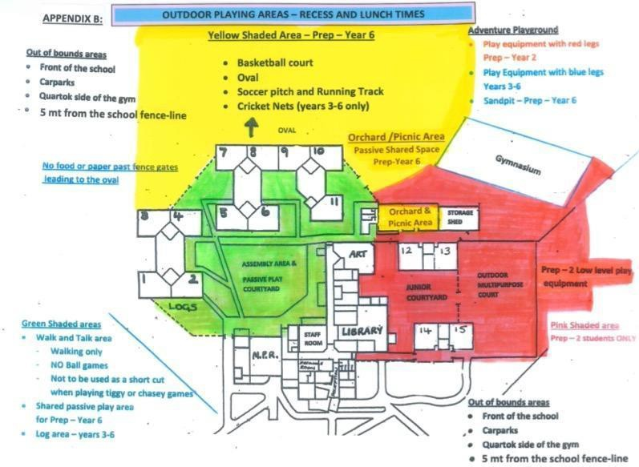

Yard duty equipment
School staff must:
- wear a provided safety/hi-vis vest whilst on yard duty. Additional safety/hi-vis vests for CRT use will be stored in the staffroom. Staff are responsible for the storage and care of their individual safety hi-vis vest.
- always carry the yard duty first aid bag / folder during supervision. The yard duty first aid bag will be stored in the staffroom and contains information about student health and safety.
- Staff are encouraged to carry their mobile phones whilst on yard duty as well.
Yard duty equipment must be returned after the period of supervision or handed to the relieving staff member.

Staff who are rostered for yard duty must remain in the designated area until they are replaced by a relieving staff member.
During yard duty, supervising school staff must:
- methodically move around the designated zone at all times to ensure adequate supervision of all areas. The teacher supervising the Adventure Playground area will maintain a line of sight of the soccer pitch when the teacher supervising the Oval & Soccer Pitch area is located near the Greaves Street North end of the oval.
- where safe to do so, approach any unknown visitor who is observed on school grounds without a clear legitimate purpose, and ensure they have a visitor pass and have signed in (excluding drop off and collection periods)
- ensure students remain in their designated year level zones
- be alert and vigilant
- intervene immediately if potentially dangerous or inappropriate behaviour is observed in the yard
- enforce behavioural standards and implement appropriate consequences for breaches of safety rules, in accordance with any relevant disciplinary measures set out in the school’s Student Engagement policy
- ensure that students who require first aid assistance receive it as soon as practicable
- log any incidents or near misses as appropriate on Compass or Edusafe
- If being relieved of their yard duty shift by another staff member (for example, where the shift is ‘split’ into 2 consecutive time periods), the staff member must ensure that a brief but adequate verbal ‘handover’ is given to the relieving staff member in relation to any issues which may have arisen during the first shift.
If the supervising staff member is unable to conduct yard duty at the designated time, they should contact the Assistant Principal with as much notice as possible prior to the relevant yard duty shift to ensure that alternative arrangements are made.
If the supervising staff member needs to leave yard duty during the allocated time, they should contact the Assistant Principal or school office but should not leave the designated area until the relieving staff member has arrived in the designated area.
If the relieving staff member does not arrive for yard duty, the staff member currently on duty should. send a message to the office/call Assistant Principal and not leave the designated area until a relieving staff member has arrived.
Students will be encouraged to speak to the supervising yard duty staff member if they require assistance during recess or lunchtime.

Classroom
The classroom teacher is responsible for the supervision of all students in their care during class. No student should be left unsupervised at any time.
A student should not be asked to leave the classroom on their own. If a student is required to be collected from the classroom for disciplinary or other reasons, the teacher must contact the office or

Wellbeing and Engagement Policy to ensure appropriate school procedures are being followed.
If a teacher needs to leave the classroom unattended at any time during a lesson, they should first contact the Assistant Principals or school office for assistance. The teacher should then wait until a replacement staff member has arrived at the classroom before leaving.

School activities, camps and excursions
The Principal and leadership team are responsible for ensuring that students are appropriately supervised during all school activities, camps and excursions, including when external providers are engaged to conduct part or all of the activity. Appropriate supervision will be planned for school activities, camps and excursions on an individual basis, depending on the activities to be undertaken and the level of potential risk involved, and will follow the supervision requirements in the Department of Education and Training Excursions Policy.

Digital devices and virtual classroom
Manorvale Primary School follows the Department’s Cybersafety and Responsible Use of Technologies Policy with respect to supervision of students using digital devices.
Manorvale Primary School will also ensure appropriate supervision of students participating in remote and flexible learning environments while on school site. In these cases, students will be supervised by a member of the leadership team in a designated area such as the library.

Students requiring additional supervision support
Sometimes students will require additional supervision, such as students with disability or other additional needs. In these cases, the Principal or delegate will ensure arrangements are made to roster additional staff as required. This may include on yard duty, in the classroom or during school activities.

Supervision of student in emergency operating environments
In emergency circumstances our school will follow our Emergency Management Plan, including with respect to supervision.
In the event of any mandatory period of remote or flexible learning our School will follow the operations guidance issued by the Department.

Other areas requiring supervision
Students must be sent in pairs when undertaking any errands or responsibilities around the school and must wear the appropriate task pass when moving around the school during class time. This includes:
- Going to the toilet
- Attending sick bay for medication purposes

Teachers need to supervise their students when moving or transitioning to different areas of the school such as other classrooms, outdoor learning spaces, the school gym or to specialist classes.

COMMUNICATION
This policy will be communicated to our school community in the following ways:
- Included in staff induction processes
- Discussed at staff briefings or meetings, as required
- Included in our staff manual
- Included as a reference in our school newsletter each semester
- Made available in hard copy from school administration upon request
Information for parents and students on supervision before and after school is available on our school website and parent reminders are sent at the beginning of each term in our school newsletter.

FURTHER INFORMATION AND RESOURCES
- the Department’s Policy and Advisory Library (PAL):
  - Child Safe Standards
  - Cybersafety and Responsible Use of Technologies
  - Duty of Care
  - Excursions
  - Supervision of Students
  - Visitors in Schools

POLICY REVIEW AND APPROVAL

Policy last reviewed | February 2026
Approved by | Principal – Brianna Morelli  Final consultation with school council on 16th February 2026
Next scheduled review date | February 2028
This policy will also be updated if significant changes are made to school grounds that require a
revision of Manorvale Primary School’s yard duty and supervision arrangements.

